The pre-trained model from Xu hao, 2019 is used here, and we have only partially fine-tuned it. Here are the results on the training and validation sets.

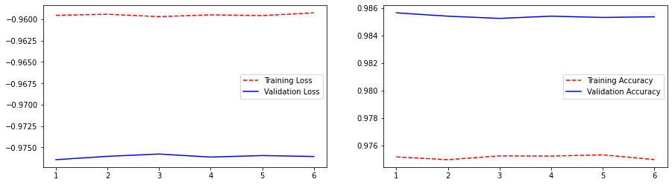

Since the original model has shown amazing results and early stopping is set here, the convergence is completed in just six Epochs. Although there is a large gap between the training set and the validation set shown in the training images. However, in terms of values, the difference between the two is only between 0.01. It can be tentatively judged that no overfitting is produced. In addition to that 97-98% accuracy is amazing and shows the performance of the model very well.

In the test set, we use the MIOU metric to measure the performance of the model. MIOU is a very common metric in image segmentation. It is represented in mathematics as the intersection-to-merge ratio. Compared to accuracy, the intersection ratio is more focused on the effectiveness of the segmented region. It is relatively more indicative of the model's strengths and weaknesses. In the MIOU metric, the MIOU value of the model in the test set is 0.95308775, with no significant decline in performance relative to the training set.

In the test set, we use the MIOU metric to measure the performance of the model. MIOU is a very common metric in image segmentation. It is represented in mathematics as the intersection-to-merge ratio. Compared to accuracy, the intersection ratio is more focused on the effectiveness of the segmented region. It is relatively more indicative of the model's strengths and weaknesses. In the MIOU metric, the MIOU value of the model in the test set is 0.95308775, with no significant decline in performance relative to the training set. The following images show the performance in specific images. A side-by-side comparison is done for mask and prediction to get a better intuition of the model's performance.

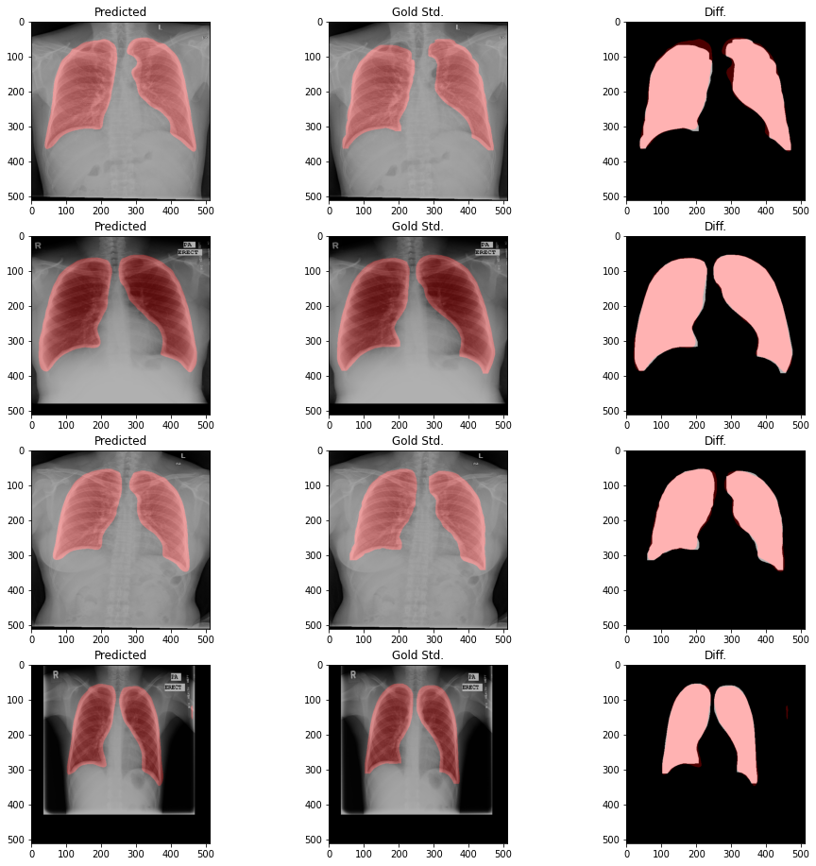

Reference

GitHub. 2022. *GitHub - zhixuhao/unet: unet for image segmentation*. [online] Available at: <https://github.com/zhixuhao/unet/> [Accessed 8 August 2022].